A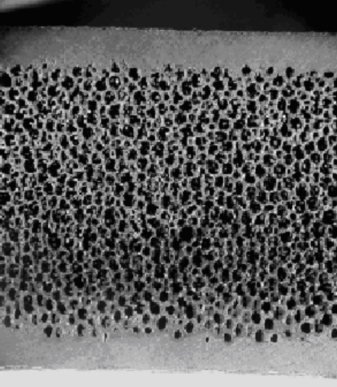 B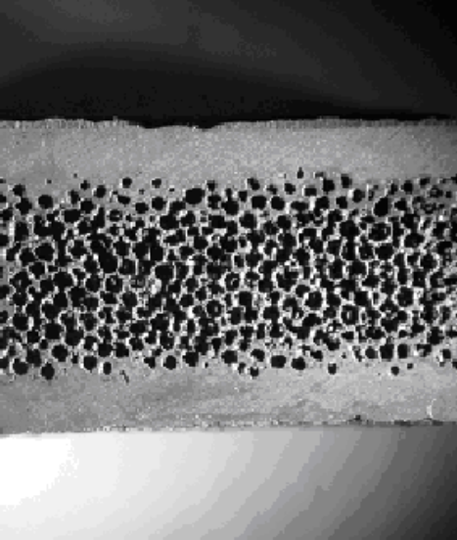

Figures 19A-B: Cross-sections of 12% dense CVD SiC foam with 1.8 mm thick CVD SiC facesheets (A) and 22% dense CVD SiC foam with 1.8 mm thick CVD SiC facesheets (B); both 5×

Strength data for the sandwich structure were established through four-point flexural testing of sandwich panel sections (Figure 24). Three specimens were tested for both the 12% and 22% dense SiC foam materials with 1.8 mm thick SiC facesheets. The parts with 12% SiC foam exhibited a flexural strength of 50.3 ± 1.4 MPa, while the parts with 22% SiC foam had a strength of 115.4 ± 7.4 MPa. As expected, the addition of the solid SiC facesheets resulted in a significant increase in strength over foam alone.

For reference, the flexure strength of 12% and 22% dense SiC foam is 3.5 and 9.0 MPa, respectively, so the addition of facesheets (and edge sheets) increased the flexure strength by 13-15X over SiC foam alone.

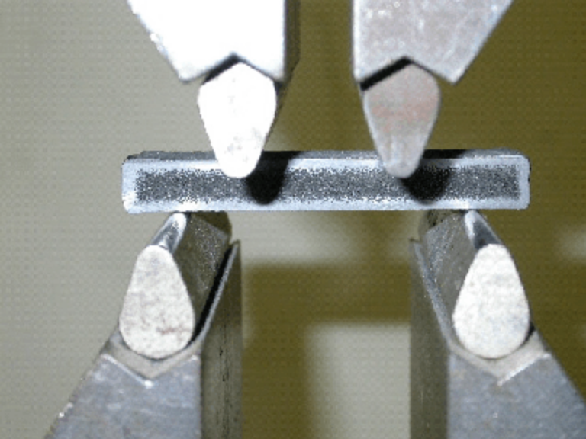

Figure 24: FCI development specimen in four-point bend fixture

